KILDARE COUNTY COUNCIL

RURAL HOUSING PLANNING APPLICATION FORM

TO BE COMPLETED FOR ALL RURAL DWELLINGS
NOTE TO APPLICANTS:
Please be aware that information submitted in relation to this application for will be held separately to the main application file and will not be available for public viewing.
Please blank out personal/financial details other than names, dates and address.

Applicant’s details. (Not agent acting on his/her behalf)

Full Name(s) and current place of residence including Eircode:
_____________________________________________________________________________________

_____________________________________________________________________________________

_____________________________________________________________________________________

_____________________________________________________________________________________

- Have the named applicants for the proposed dwelling resided in the rural area of County Kildare for 16 years?

Yes No

- (a) Have the named Applicant(s), ever owned a dwelling, or previously been granted planning permission for a dwelling in County Kildare?

Yes No

(b) Where Yes, please clarify the need for a dwelling in a rural area in County Kildare and provide planning reference number of permitted dwelling.
______________________________________________________________________________________

______________________________________________________________________________________

- Who will occupy the proposed dwelling house? ___________________________________________

- Into which category of Local Need as per the Rural Housing Policy Zones set out in the Kildare County Development Plan 2023-2029 is it considered that the Applicant(s) would comply with? Please see table below and map on page 7 of this form for information regarding categories and zones. Please also refer to Section 3.13.3 of the Kildare County Development Plan 2023-2029 for further definitions of categories.

Category A refers to an economic need such as a farmer or owner and operator of a farming/ horticultural/ forestry/ bloodstock/ animal husbandry business who is actively engaged in farming.

Category B refers to a social need such as a member of the rural community.

Zone 1 Zone 2 See map attached.

AND

Category A: (i) Category A: (ii) Category B: (i)

Category A – Economic | Relevant Documents  Required | Documents submitted  (Please tick)
(i) A *farmer of the land or the son/daughter/niece/nephew of the farmer who it is intended will take over operation of the family farm, building on the landholding | - Copy of deeds indicating landholding of minimum 15ha in the ownership of the Applicants immediate family for a minimum of 7 years preceding the date of the application for planning permission.
 | - Evidence of any additional leased lands, if applicable - Lands that are leased will only be considered where the lease is in place for a period of 10 or more years.
 | - Certified copy of land registry map and folio or deeds indicating all lands in you or your family’s ownership.
 | - Documentary evidence demonstrating the Applicant’s employment in farming.
(ii) An owner and operator of a farming/horticultural/forestry/bloodstock/Animal husbandry business on an area less than 15ha, building on the landholding | a) Certified copy of land registry map and folio and deeds indicating all land in Applicant’s ownership.
b) Documentary evidence demonstrating that the Applicant is engaged in farming/horticultural/ forestry/ bloodstock/ animal husbandry business on a daily basis which forms a significant part of the Applicant’s livelihood, including intensive farming
See attached guidance on page 8

*Farmer for this purpose, is defined as a landowner with a holding of more than 15ha

Category B - Social | Relevant Documents Required | Documents submitted  (Please tick)
(i) A person who has resided in a rural area for a substantial period of their lives (16 years) within an appropriate distance of the site where they intend to build on the family landholding.  Note: Where no land is available in the family ownership, a site within 5km of the applicant’s family home may be considered. | - Eircode(s) of dwelling(s) where applicant resided for 16 year period
 | - Letter from school(s) indicating years of attendance and address at time of attendance.
 | - Birth certificate – long version
 | - Utility bills and other evidence substantiating link to rural area (within the period of the 16 years). E.g., correspondence from banking, insurance, Revenue, etc. with names, address and dates clearly visible.
- Map indicating:
- Dwelling(s) where applicant resided for 16 year period,
- Immediate family members in the area, and
- The subject site.
 | - Certified copy of land registry map and folio or deeds indicating all land in you or your family’s ownership.
 | - Letter confirming that you have not owned or been permitted a dwelling previously (certified by Commissioner of Oaths/solicitor)

- Is your current accommodation: Owned Rented Other (specify below)

_____________________________________________________________________________________

_____________________________________________________________________________________

- (a) State the full name and address of the person from whom the site has or will be acquired:
______________________________________________________________________________________

______________________________________________________________________________________

(b) State applicant’s family relationship, if any, to person named at (a)

______________________________________________________________________________________________

______________________________________________________________________________________________

- (a) Have you submitted a certified copy of land registry map and folio or deeds indicating all land in you or your family’s ownership., showing all land in the ownership of the person named in Q6(a) in Co. Kildare. Please note that a failure to submit this information will result in delays with the processing of this application.
Yes No

(b) Have you submitted a map showing all land/plots sold from the original landholding? A map of the entire landholding from which the site is taken must be submitted - not just the field in question. Please note that a failure to submit this information will result in delays with the processing of this application.

Yes No

(c) Confirm reference numbers of all previous residential planning permissions permitted on the original landholding and include a map indicating the location and owners:

___________________ _________________ ___________________

___________________ _________________ ___________________

- Is the proposed site/dwelling for:
Applicant’s own Occupation Sale Other (Please specify below)

_____________________________________________________________________________________

_____________________________________________________________________________________

- Are you aware, in the event that planning permission is granted, an occupancy condition will be applied, and in some cases a Section 47 agreement in accordance with the Act (Planning & Development Act 2000 as amended), restricting residency to the applicant for a period of 10 years, will be attached?

Yes No

- (a) Derelict Dwelling (structure in a ruinous or dangerous condition, incapable of restoration as per Section 3.13.5 of the County Development Plan 2023-2029). Is the application for the replacement of a derelict dwelling?

Yes No

(b) If YES, which category of Local Need do you consider yourself to comply with?
(Question 4 will be evaluated for compliance, so please ensure this is filled out in full)

___________________________________________________________________________________

___________________________________________________________________________________

- Replacement of existing habitable dwelling (See Section 3.13.5 of the County Development Plan 2023-2029)
(a) When was the dwelling last occupied? (Please provide documents to support same e.g., utility bills etc.)
___________________________________________________________________________________

___________________________________________________________________________________

(b) Have you provided a report from a suitably qualified competent person to verify that the dwelling is habitable but that a replacement dwelling is the most suitable option? (Please provide said documents.)

Yes No

(c) Are you aware, in the event that planning permission is granted, that a condition will be applied requiring the existing dwelling (to be replaced) to be demolished?

Yes No

13. Applicant is a resident of an adjoining County (see section 3.13.6 of the Kildare County Development Plan 2023-2029). In addition to the completion of Section 13, it is necessary to also complete in full Section 4 of this application form.

Category of Applicant | Relevant Documents  Required | Documents submitted  (Please tick)
It is the policy of the Council:  To consider applications for one-off housing, in areas bordering neighbouring counties, where the proposed site is located on family land within County Kildare, at a distance of up to 2 km located in Zone 1 and up to 5 km in Zone 2, from the county boundary. Applicants will be required to demonstrate, to the satisfaction of the planning authority, that no suitable family-owned site is available in the adjoining county and that all other aspects of rural housing policy including local need, siting and design are complied with and that no significant negative environmental effects will occur as a result of the development. The applicant shall also fully demonstrate that they are building their first rural dwelling and that it will be for their permanent place of residence. | - Eircode and map showing location of family home place in adjoining county and subject site in County Kildare.
 | - Utility bills and other evidence substantiating link to rural area (within the period of the 16 years).
 | - Letter stating reason why no suitable family-owned site is available in the adjoining County.
 | - Signed declaration (copies certified by Commissioner of Oaths/solicitor) that the applicant(s) has/have not built a dwelling in a rural area of the adjoining County.
 | - Certified copy of land registry map and folio or deeds indicating all land in family ownership in County Kildare and the adjoining county.

Signature of Applicant(s): ________________________________

Date: ________________________________
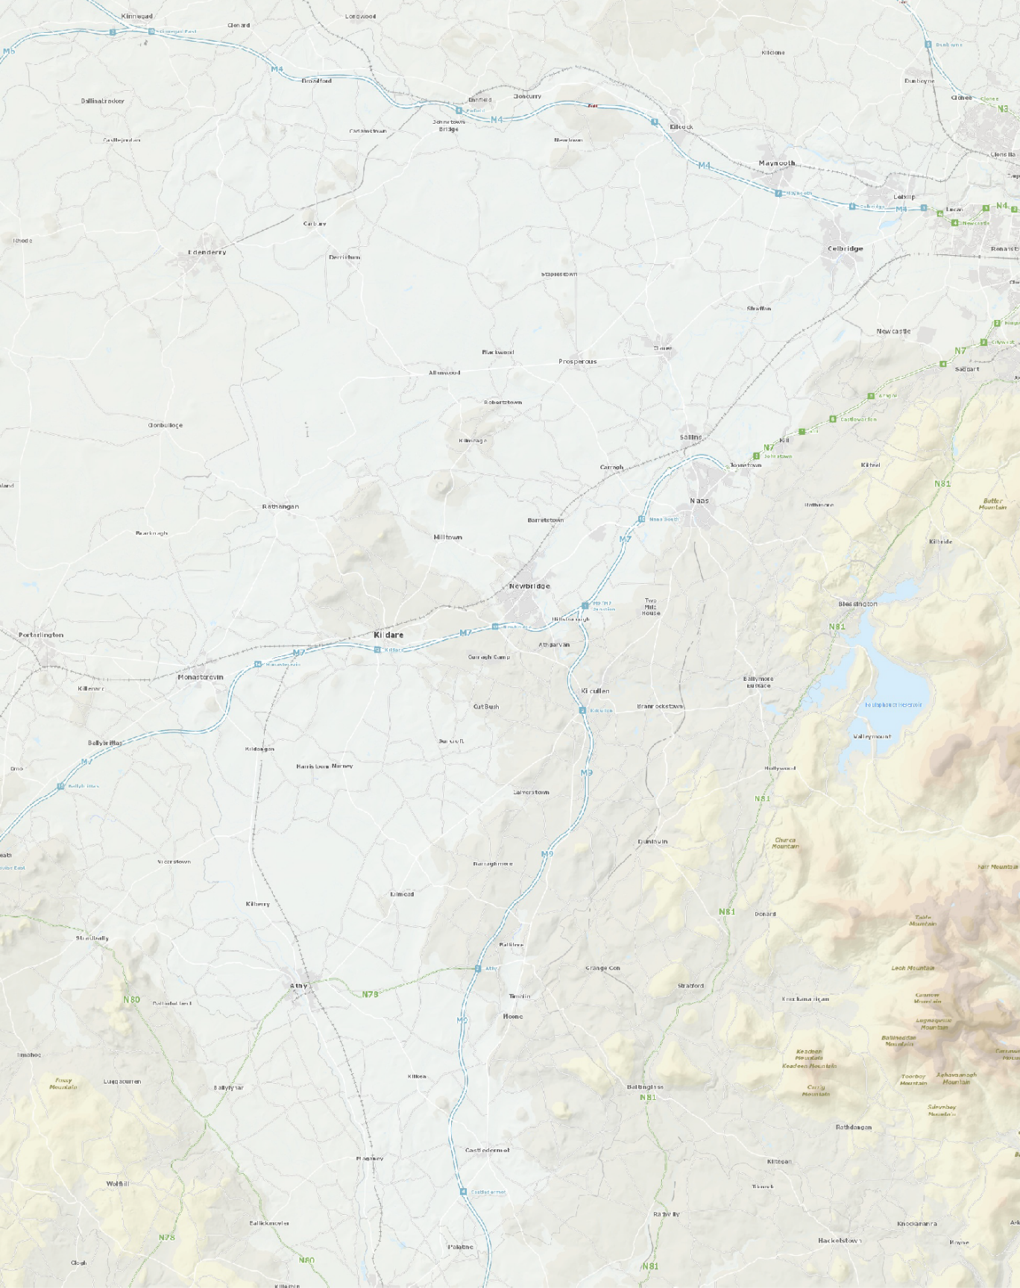
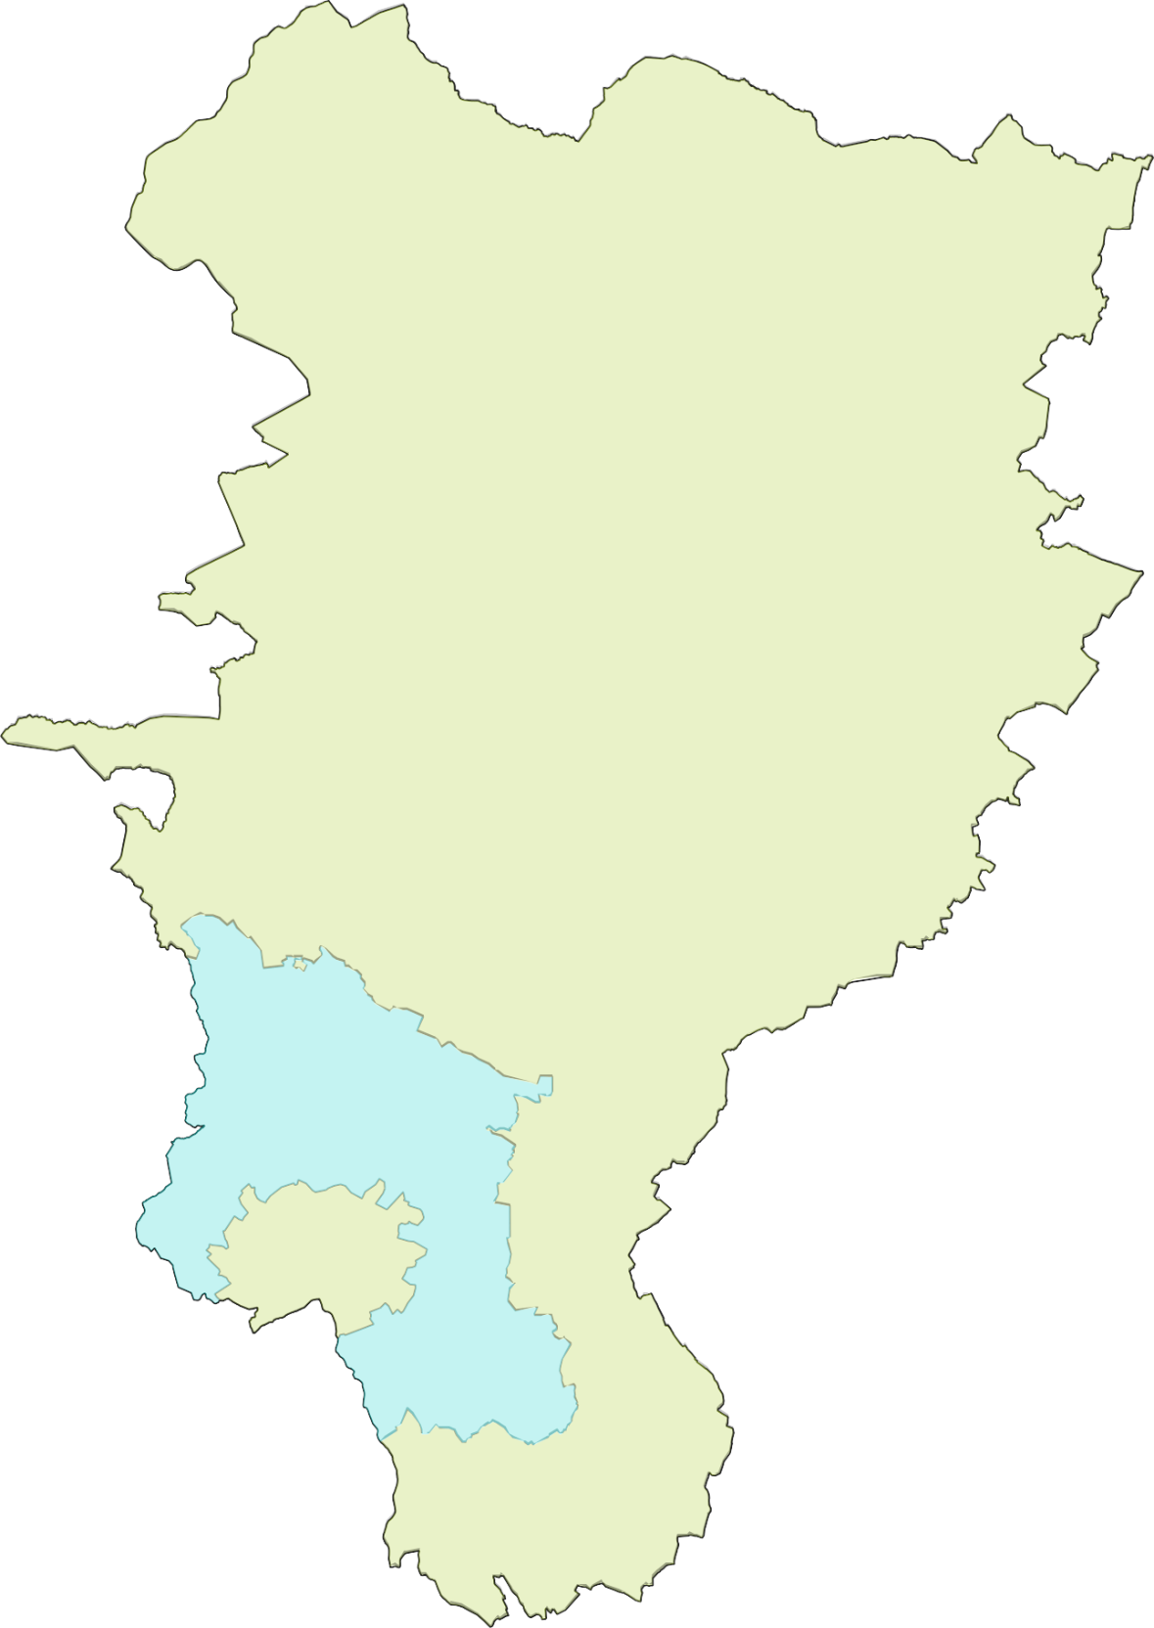
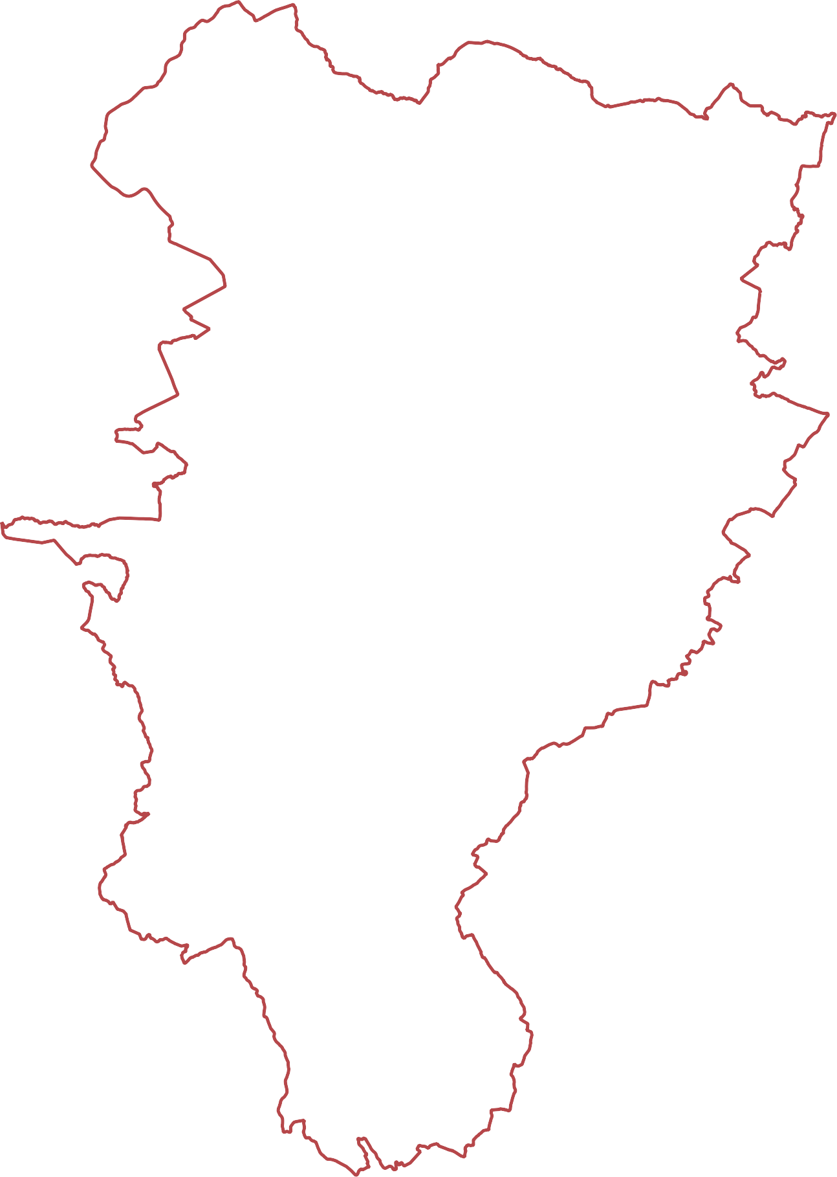
Legend

Rural Housing Policy Zones

Zone 1

Zone 2
Guidance on Question 4 of this application form for demonstrating a need under Category A (ii):
(ii) An owner and operator of farming/horticultural/forestry/bloodstock/animal husbandry business on an area less than 15ha, who is engaged in farming activity on a daily basis, where it is demonstrated through the submission of documentary evidence that the farming/agricultural activity forms a significant part of their livelihood, including but not limited to intensive farming.

The Applicant should provide an overview of their business operations and submit supporting documentation from the following suggested range of categories (not exhaustive). Please note that this is a list suggesting the type of relevant information only, and all documents mentioned will not be relevant to every Applicant. Please also note information regarding GDPR (data protection) from page 9 onwards.

Official Registrations:
Extent of holding, freehold, land registry records deeds etc.
Company Registration Number
Herdowner Number
Herd Number/Flock number
Equine Premises Number
Registrations and other Identifiers with DAFM and relevant sub-unit e.g., IACS
Note: Above registrations to be official/letterheaded correspondence with Applicant’s name/address visible alongside number etc.
Memberships & Licences
Licence Number and details
Certification Bodies - E.g. Organic Certification Board, Irish Organic Association, Bord Bia Quality Assurance, Sustainable Beef and Lamb Assurance Scheme, Irish Creamery Milk Suppliers Association, GLAS, ACRES
Irish Thoroughbreds Association, Horse Racing Ireland
Breed Societies (e.g. Limousin, Charolais cattle; Suffolk, Cheviot sheep etc.)
Schemes/Payments/Supports
BPS/BISS application/payment evidencing active farmer
Other payments/supports e.g. CFGS, GLAS, ACRES, FES, TAMS, OFS, REAP, Afforestation Scheme, Agro Forestry, Commercial Horticulture etc.
Extent of Operation and Intensity
Stock Numbers, Type of Enterprise, Stocking Rate Statement
No. loose boxes, foaling boxes, stallion boxes.
Equine Passports/Weatherby’s
Covering certificates
Extent of growing area, where applicable, area of glass/polythene/outdoor bed/house dimensions, shelving/racking type etc.
Geotagged photos evidencing area operational
Details of employees
Financial
Statement of Accounts
Income and Expenditure details EG. Mart, Factory, Wool, Sales of Crop, BPS, grant monies, Sales receipts Goffs/Tatts etc. Supplies, Agri supplies, Veterinary, Farrier, Feed, Bedding, Labour, Entries
P21 Balancing statement for other employment
Organisations/Advisory/Networking Groups
E.g., IFA, Teagasc
Membership certificates
Qualifications
Relevant Educational Qualifications (e.g. Agricultural Science, Green Cert)
Specialist Training/Qualifications

Data Protection Act 2018
PRIVACY STATEMENT
Who are we?
Kildare County Council (the Council) is the democratically elected unit of Local Government in County Kildare and is responsible for providing a range of services to meet the economic, social and cultural needs of the people of our County. In order to provide the most effective and targeted services to meet the needs of the citizens, communities and businesses of County Kildare we will be required to collect, process and use certain types of information about people and organisations. Depending on the service being offered, information sought may include ‘personal data’ as defined by the Data Protection Acts and the General Data Protection Regulation (GDPR) and may relate to current, past and future service users; past; current and prospective employees; suppliers; and members of the public who may engage in communications with our staff. In addition, staff may be required, from time to time, to collect process and use certain types of personal data to comply with regulatory or legislative requirements or to carry out functions in the public interest.
Why do we have a Privacy Statement?
This privacy statement has been created to demonstrate the Council’s commitment that personal data you may be required to supply to us, to enable us to provide services, is;
- Obtained lawfully, fairly and in a transparent manner
- Obtained for only specified, identified and legitimate purposes
- Processed for purposes which we have identified or purposes compatible with the purposes that we have identified.
- Adequate, relevant and limited to what is necessary for purpose for which it was obtained
- Personal data collected and processed must be accurate and (where necessary) kept up to-date.
- Kept only for as long as is necessary for the purposes for which it was obtained.
- Processed in a manner that ensures the appropriate security of the personal data including protection against unauthorised or unlawful processing.
More detail is available in our Data Protection Policy at http://kildare.ie/CountyCouncil/DataProtection/ or you can request a hard copy at 045 980 200.

What is the activity referred to in this Privacy Statement?
Kildare County Council performs the role of Planning Authority for the County. The planning application process is a statutory requirement which allows for the relevant parties and public to participate in the proper development of the lands in the County.

What is the basis for making the processing of this personal data lawful?
Processing is necessary for the performance of a task carried out in the public interest or in the exercise of official authority vested in Kildare County Council in accordance with Article 6(1)(e) of the General Data Protection Regulation,2016. Specifically the lawful basis for this process is the Planning & Development Acts 2000- 2017 and the Planning and Development Regulations 2001 - 2017. In addition there are also certain delegated functions under the local Government Reform Act 2014.

We require contact details
In order to communicate with you, you will be asked for contact details. You do not have to provide all contact details but providing more, such as email, phone, address, makes it easier to communicate. Please note that to help protect your privacy, we take steps to verify your identity before granting access to personal data. These contact details may also be used to verify your identity.
What other types of personal data do we need to undertake this activity?
(a) Data subject - Name, address, contact number, copy of payment receipt, local needs information & supporting documentation which may include documents such as birth certificate, baptismal certificate, credit union details, copy of driving licence, copy of passport, school documentation etc.
(b) Third parties related to the land - name, address, land ownership
(c) Third parties - information related to submissions made to the Planning Authority (Elected Representatives)
Medical records and potentially other sensitive data can be processed under the rural housing local need aspect of this activity. This information is not requested; however it may be voluntarily submitted as part of the application.
What will happen if the personal data is not provided?
All information requested as part of the application process, (excluding the rural housing local need information) is mandatory as part of the application process and is required for the application to be considered valid. Any application deemed invalid will not proceed. If the local need information is not submitted, the planner may refuse or request further information on the file in order to satisfy the Planning Authority that the applicant is compliant with the Rural Housing policy of the Kildare County Development Plan 2017-2023
Am I the only source of this personal data?
In some instances to assist with the delivery of the activity or to comply with regulatory or legislative requirements personal data is sourced from a third party. This may apply to this activity.
Data may be sourced during the planning application process from public sources such as the Property Registration Authority and other publically available information that Kildare County Council may hold.
Is personal data submitted as part of this activity shared with other organisations?
The Council may, to fulfil statutory or regulatory obligations or in the public interest, from time to time, have to share personal data with other organisations or entities (in Ireland or abroad). Where this is required the Council shall have regard to your rights, to the security and integrity of the data and will minimise the data shared.

Sharing APPLIES to this activity.

As part of this process, the planning application data which is publicly available may be forwarded to external agencies/consultees such as ESB, Irish Rail, etc. to review and make a submission if they wish. If an application is to be appealed Kildare County Council are required under the Planning and Development Acts to give all details submitted as part of the planning application to An Bord Pleanála, who then become the joint data controller for the information they hold.

Data IS NOT transferred to another country.

Data is transferred to (if there are no countries listed, it is not intended to transfer the personal data abroad)
How long is my data kept for?
The Council has a detailed record retention policy which outlines time periods for which your personal data will be retained and what will happen to it after the required retention period has expired. A copy of Record Retention Policy can be accessed via the following link: http://www.lgma.ie/sites/default/files/2002_national_retention_policy_for_local_authority_records_2.pdf

Do you need to update your records?
Kildare County Council must take reasonable steps to ensure that personal data we have about our customers is correct and up to date.
In addition, if the data held by us is found to be inaccurate you have the right to rectify/correct this.
If you find that personal data we have about you is inaccurate or needs to be updated (for instance, you may have changed your name, address, contact details etc.) then please contact us so that we can correct it. You can do this by:

Writing to us at: Kildare County Council, Áras Chill Dara, Devoy Park, Naas, Co Kildare. W91 X77F
Emailing us at customercare@kildarecoco.ie

When making a request to update your record please provide evidence to support this - for example a copy of a document containing your new address – utility (Gas, Electricity, Phone) bill etc.

Your rights:
You have the right to obtain confirmation as to whether data concerning you exists, to request access to personal data held about you, to be informed of the content and source of data and check its accuracy.
If the data held by us is found to be inaccurate you have the right to rectify/correct this – see above on how to update your records.
You also, subject to certain conditions being met, have the right to object to or seek restriction of the processing of personal data and to request the erasure of personal data held by the Council.

Please note that to help protect your privacy, we take steps to verify your identity before granting access to personal data.
To exercise these rights logon to http://kildare.ie/CountyCouncil/DataProtection/ , use one of the forms at our Counter or contact us.
Kildare County Council - Access to Information Officer
Phone | 045 982 200
E-mail | dataprotection@kildarecoco.ie or customercare@kildarecoco.ie
Postal Address | Áras Chill Dara,  Devoy Park,  Naas,  Co Kildare. W91 X77F.
Right of Complaint to the Data Protection Commissioner
If you are not satisfied with the outcome of the response received by the Council you are entitled to make a complaint to the Data Protection Commissioner who may investigate the matter for you. The Data Protection Commissioner’s website is www.dataprotection.ie or you can contact their Office at:

Lo Call Number | 1890 252 231
E-mail | info@dataprotection.ie
Postal Address | Data Protection Commissioner  Canal House  Station Road  Portarlington, Co. Laois. R32 AP23.
Changes to Privacy Statement
We may make changes to this Statement. If we make any changes they will be posted on this page and we will change the “Last Updated” date below.

Privacy Statement Last Updated 25 May 2018.

